|  |  |
| --- | --- |
| **Name:** | Bodhisatya Ghosh |
| **Branch:** | CSE – Data Science |
| **Batch:** | B |
| **Course:** | Soft Computing |
| **Experiment no:** | 3 |

**Aim:** To implement Multilayer Perceptron Learning algorithm (EBPTA).

**Theory:** This learning algorithm is applied to multilayer feed-forward networks consisting of processing elements with continuous differentiable activation functions. The networks associated with back-propagation learning algorithm are also called back-propagation networks (BPNs). For a given set of training input-output pair, this algorithm provides a procedure for changing the weights in a BPN to classify the given input patterns correctly. The basic concept for this weight update algorithm is simply the gradient-descent method as used in the case of simple perceptron networks with differentiable units.

This is a method where the error is propagated back to the hidden unit. The aim of the neural network is to train the net to achieve a balance between the net’s ability to respond (memorization) and its ability to give reasonable responses to the input that is similar but not identical to the one that is used in training (generalization)

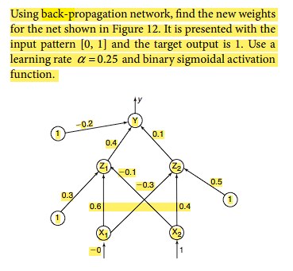

**Program:**

#include <stdio.h>

#include <stdlib.h>

#include <math.h>

void print_neurons(float* arr,int num,char* c){

    printf("%s\n",c);

    for(int i = 0; i < num ; i++){

        printf("%f ",arr[i]);

    }

    printf("\n\n");

}

void print_weights(float** arr,int row, int col){

    printf("Weights are :\n");

    for(int i = 0; i < row ; i++){

        for(int j = 0; j < col; j++){

            printf("%f ",arr[i][j]);

        }

        printf("\n");

    }

    printf("\n");

}

void print_bias(float* bias,int neuron_cnt,char* c){

    printf("%s\n",c);

    for(int i = 0; i < neuron_cnt; i++){

        printf("%f ",bias[i]);

    }

    printf("\n\n");

}

float* allocate_neuron(float* arr,int size,char* desc){

    printf("Allocating %d %s\n",size,desc);

    arr = (float*)malloc(size * sizeof(float));

    return arr;

}

float** fill_weights(float** weights,int i,int j,char* desc){

    weights = (float**)malloc(i * sizeof(float*));

    for(int x = 0; x<j ; x++){

        weights[x] = (float*)malloc(j * sizeof(float));

    }

    printf("Weights from %s\n",desc);

    for(int a = 0; a < i; a++){

        for(int b = 0; b < j; b++){

            printf("Enter weight for neuron %d to neuron %d: ",a+1,b+1);

            scanf("%f",&weights[a][b]);

        }

    }

    printf("\n");

    return weights;

}

float activation_function(float x){

    float ans = (float)(1/(1+exp(-x)));

    return ans;

}

float diff_activation_function(float x){

    float ans = activation_function(x)*(1-activation_function(x));

    return ans;

}

void feedforward(float* layer1,float* layer2,float* layer2_in,int layer1_size,int layer2_size, float* bias, float** weights){

    printf("Feeding forward\n");

    for(int i = 0 ; i < layer2_size; i++){

        float zin = bias[i];

        for(int j = 0; j < layer1_size; j++){

            zin += layer1[j]*weights[j][i];

        }

        layer2[i] = activation_function(zin);

        layer2_in[i] = zin;

        printf("Finished one neuron to neuron\n\n");

    }

}

void backpropagate_final(float*y, float* yin,int neuron_count,float* error_sigma,float target){

    for(int i = 0; i < neuron_count; i ++){

        error_sigma[i] = (target - y[i]) * diff_activation_function(yin[i]);

    }

}

void backpropagate_hidden(float* hidden_layer_error_sigma,float* output_layer_error_sigma,float* hidden_layer_input,float** weight,int hidden_neurons,int output_neurons){

    for(int i = 0 ;i < output_neurons;i++){

        for(int j = 0; j < hidden_neurons; j++){                        // As error sigma was not initilaized, this will not work for nets with

            hidden_layer_error_sigma[j] = output_layer_error_sigma[i] * weight[j][i];      //more than one output neuron

        }

    }

    for(int i = 0; i<hidden_neurons; i++){

        hidden_layer_error_sigma[i] = hidden_layer_error_sigma[i] * diff_activation_function(hidden_layer_input[i]);

    }

}

void update_weights(float** weight,float* input,int row,int col,float* error_sigma,float learning_rate,float* bias){

    for(int i = 0; i < col; i++){

        for(int j = 0; j < row; j++){

            weight[j][i] = weight[j][i] + (learning_rate * error_sigma[i] * input[j]);

        }

        bias[i] = bias[i] + (error_sigma[i] * learning_rate);

    }

}

void main()

{

    float* x;       //input

    float** v;      //input to hidden weights

    float* z;       //hidden

    float* zin;       //hidden

    float** w;      //hidden to output

    float* y;       //output

    float* yin;       //output

    float* output_error;    //backpropagating error from output neuron(s)

    float* hidden_error;    //backpropagating error from hidden neuron(s)

    float bias_hidden[] = {0.3,0.5};  //biases

    float bias_output[] = {-0.2};

    int n,p,m;      // neuron numbers

    float learning_rate,target;     //learning rate and target

    printf("Enter number of input neurons: ");

    scanf("%d",&n);

    printf("Enter number of hidden layer neurons: ");

    scanf("%d",&p);

    printf("Enter number of output neurons: ");

    scanf("%d",&m);

    printf("Enter learning rate: ");

    scanf("%f",&learning_rate);

    printf("Enter target: ");

    scanf("%f",&target);

    printf("\n");

    x = allocate_neuron(x,n,"input layer neurons");

    zin = allocate_neuron(zin,p,"hidden layer neurons inputs");

    z = allocate_neuron(z,p,"hidden layer neurons");

    yin = allocate_neuron(yin,m,"output layer neurons inputs");

    y = allocate_neuron(y,m,"output layer neurons");

    hidden_error = allocate_neuron(hidden_error,p,"error propagation for hidden layer");

    output_error = allocate_neuron(output_error,m,"error propagation for output layer");

    for(int i = 0; i < n; i++){

        printf("Enter input neuron %d: ",i+1);

        scanf("%f",&x[i]);

    }

    print_neurons(x,n,"Input neurons");

    v = fill_weights(v,n,p,"input layer to hidden layer");

    w = fill_weights(w,p,m,"hidden layer to output layer");

    feedforward(x,z,zin,n,p,bias_hidden,v);

    print_neurons(z,p,"Hidden neurons");

    feedforward(z,y,yin,p,m,bias_output,w);

    print_neurons(y,m,"Output neurons");

    backpropagate_final(y,yin,m,output_error,target);

    backpropagate_hidden(hidden_error,output_error,zin,v,p,m);

    update_weights(w,z,p,m,output_error,learning_rate,bias_output);

    update_weights(v,x,n,p,hidden_error,learning_rate,bias_hidden);

    printf("V ");

    print_weights(v,n,p);

    print_bias(bias_hidden,p,"Hidden layer bias");

    printf("W: ");

    print_weights(w,p,m);

    print_bias(bias_output,m,"Output layer bias");

}

//2 2 1 0.25 1 0 1 0.6 -0.3 -0.1 0.4 0.4 0.1

**Results:**

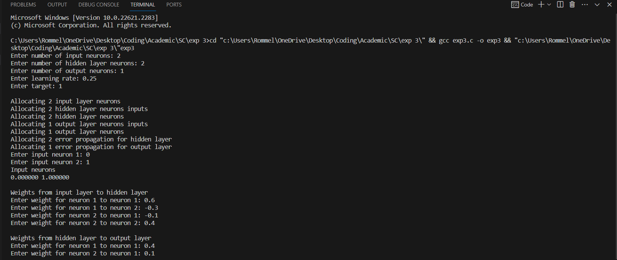

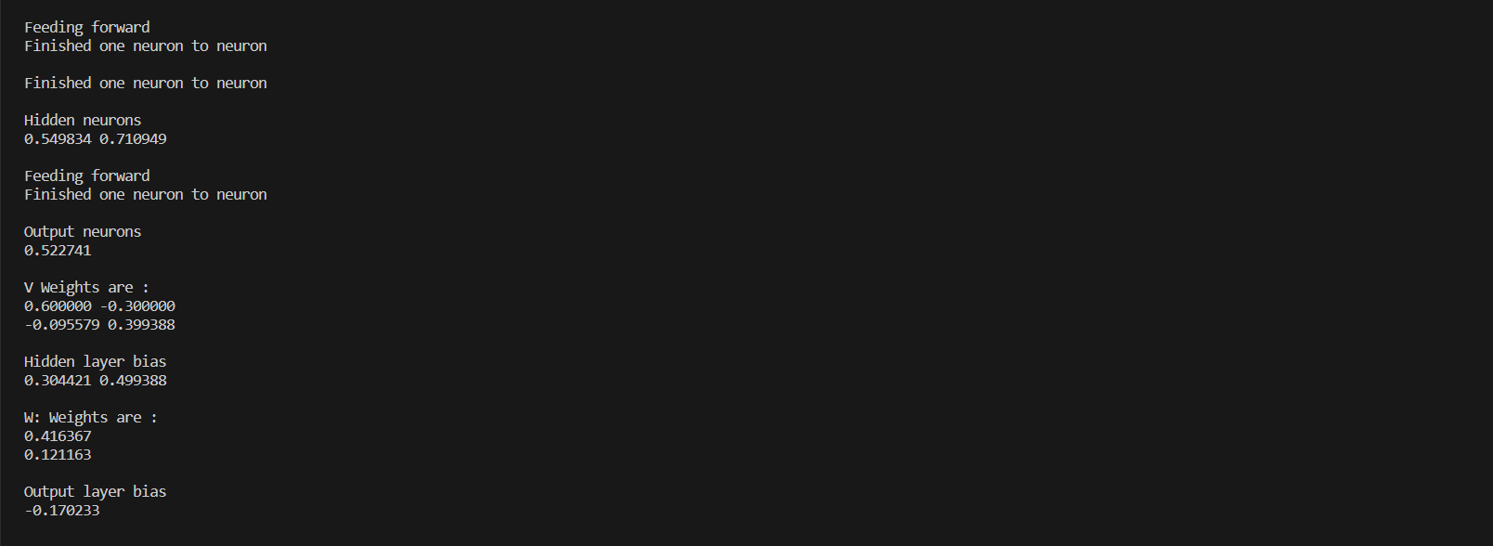

**CONCLUSION: -** In this experiment we studied about multilayer perceptron learning algorithm with back-propagation.